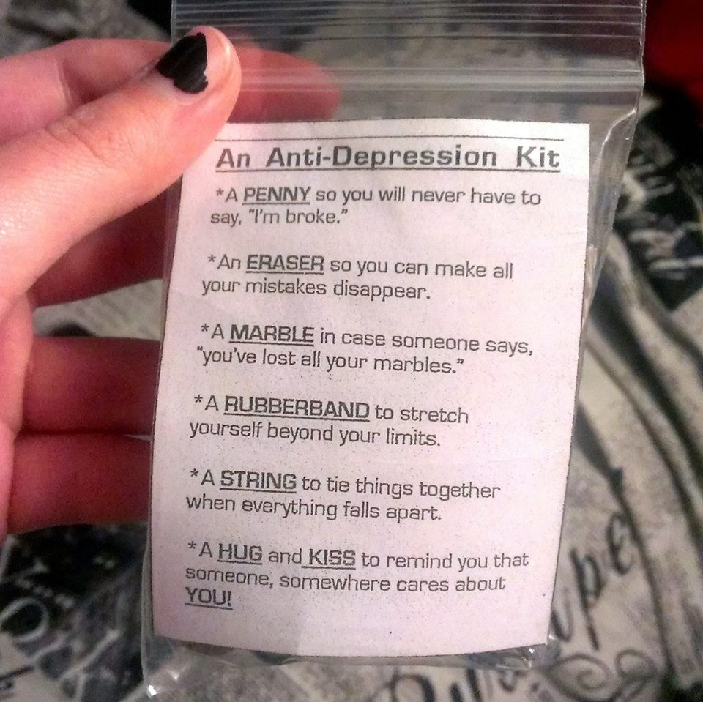
Materials:
- Penny(s)
- Eraser(s)
- Marble(s)
- Rubber band(s)
- String Cut to desired Length and color of choice I recommend 1 Foot
- Jeweler pouches – Ziplocs 2” X 3” Baggies Work for thes when they print exactly as created.
Printer- to print the page of “AN ANTI-DEPRESSION KIT” seen bellow. Each sheet makes 6 kits. You will need the above materials one for each of the 6 kits printed or as needed. In WORD you can select FILE, then PRINT, then PRINT ALL PAGES and in the box type in 2 (PRINT CUSTOM RANGE) and only print the page below without having to continually print these instructions.

AN ANTI-DEPRESSION KIT  - A PENNY so you will never have to Say, “I’m broke.”  - An ERASER so you can make all your mistakes disappear.  - A MARBLE in case someone says, “You’ve lost all your marbles.”  - A RUBBERBAND to stretch yourself beyond your limits.  - A STRING to tie things together when everything falls apart.  - A HUG and KISS to remind you that someone, somewhere cares about YOU! | AN ANTI-DEPRESSION KIT  - A PENNY so you will never have to Say, “I’m broke.”  - An ERASER so you can make all your mistakes disappear.  - A MARBLE in case someone says, “You’ve lost all your marbles.”  - A RUBBERBAND to stretch yourself beyond your limits.  - A STRING to tie things together when everything falls apart.  - A HUG and KISS to remind you that someone, somewhere cares about YOU! | AN ANTI-DEPRESSION KIT  - A PENNY so you will never have to Say, “I’m broke.”  - An ERASER so you can make all your mistakes disappear.  - A MARBLE in case someone says, “You’ve lost all your marbles.”  - A RUBBERBAND to stretch yourself beyond your limits.  - A STRING to tie things together when everything falls apart.  - A HUG and KISS to remind you that someone, somewhere cares about YOU!

AN ANTI-DEPRESSION KIT  - A PENNY so you will never have to Say, “I’m broke.”  - An ERASER so you can make all your mistakes disappear.  - A MARBLE in case someone says, “You’ve lost all your marbles.”  - A RUBBERBAND to stretch yourself beyond your limits.  - A STRING to tie things together when everything falls apart.  - A HUG and KISS to remind you that someone, somewhere cares about YOU! | AN ANTI-DEPRESSION KIT  - A PENNY so you will never have to Say, “I’m broke.”  - An ERASER so you can make all your mistakes disappear.  - A MARBLE in case someone says, “You’ve lost all your marbles.”  - A RUBBERBAND to stretch yourself beyond your limits.  - A STRING to tie things together when everything falls apart.  - A HUG and KISS to remind you that someone, somewhere cares about YOU! | AN ANTI-DEPRESSION KIT  - A PENNY so you will never have to Say, “I’m broke.”  - An ERASER so you can make all your mistakes disappear.  - A MARBLE in case someone says, “You’ve lost all your marbles.”  - A RUBBERBAND to stretch yourself beyond your limits.  - A STRING to tie things together when everything falls apart.  - A HUG and KISS to remind you that someone, somewhere cares about YOU!

